How to upload a file – drag and drop
This skills sheet will explain how tutors can upload a file to Moodle using the new drag and drop functionality. Simply drag a file from your documents folder (or from any other folder for that matter) and drop it into your Moodle course.
NB: Please note that currently this feature is only supported in the following browsers: Internet Explorer 10, Firefox 4, Safari and Google Chrome.
- Click the Turn editing on button (top right of the screen).

- Select the section (topic) of the course you would like to add the file to.

- Now make sure both Moodle and the folder the file is saved in are both visible on screen. If you are using Windows 7, you can snap the windows so they sit side-by-side.

- Drag the file(s) and drop it into your Moodle course. After a few seconds the file will start to upload and a progress bar will appear.
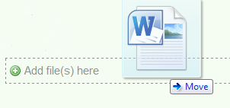
You can drag and drop multiple files into Moodle meaning you can populate a course with resources within minutes.

- Once the file has successfully uploaded it will be immediately available to students enrolled on the module.
NB: Please note the following
- Where possible the file will open within the course interface; otherwise students will be prompted to download it.
- You can add multiple files by selecting more than one and dragging them into the relevant place in Moodle.
- Students are able to drag and drop files when submitting assignments.
- Tutors can drag and drop files when returning marked assignments for students.

