How to upload a file to Moodle
This skill sheet will demonstrate how tutors can upload a file to a Moodle course.
- Click the Turn editing on button (top right of the screen).

- Select the section (topic) of the course you would like to add the file to. Now click the Add an activity or resource link. The Add an activity or resource window will open.

- Under the Resources heading, select File and then click Add. This will launch the Adding a new File page.

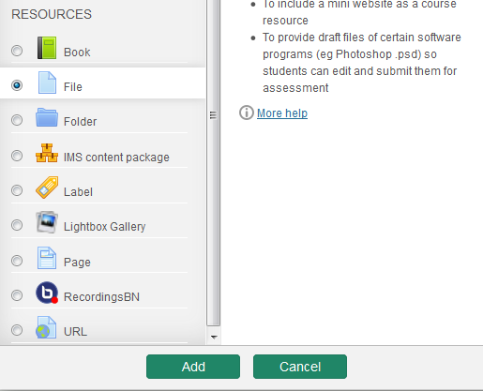

- Give the File a Name – this is the link the students will click on from the main course page to open the file so make sure it’s something relevant.

- Add a Description – provide a brief summary of the resource. You can make the description available on the course page by selecting Display description on course page.
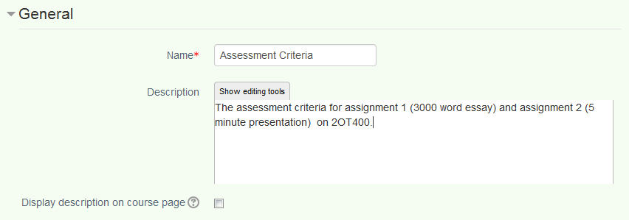

- Now in the Content section –you can either drag and drop you files to upload them or add them using the File Picker. Drag the file(s) and drop it into your Moodle course. After a few seconds the file will start to upload and a progress bar will appear.
NB: Please note that the drag and drop functionality is only supported in the following browsers: Internet Explorer 10, Firefox 4, Safari and Google Chrome.
To upload using the file picker, click Add and browse for the file you would like to upload. Click the Upload this file button to complete the process.
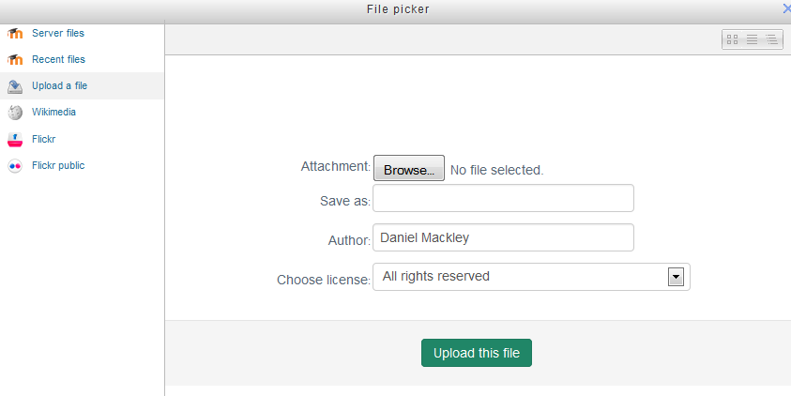
- Scroll down until you see the Options for displaying the resource. By default the display option is set to opening the resource in a New window. This can be changed by selecting your preferred option from the drop down menu. You also have the option to show both the size of the document and document type on the course page – select the relevant boxes if you wish to do so.
- To finish, scroll to the bottom of the page and click on the Save and return to course button.
NB: Please note the following
- Where possible the file will open within the course interface; otherwise students will be prompted to download it.
- You can add multiple files by selecting more than one and dragging them into the relevant place in Moodle.
- Students are able to drag and drop files when submitting assignments.
- Tutors can drag and drop files when returning marked assignments for students.

